Jigsaw content overview
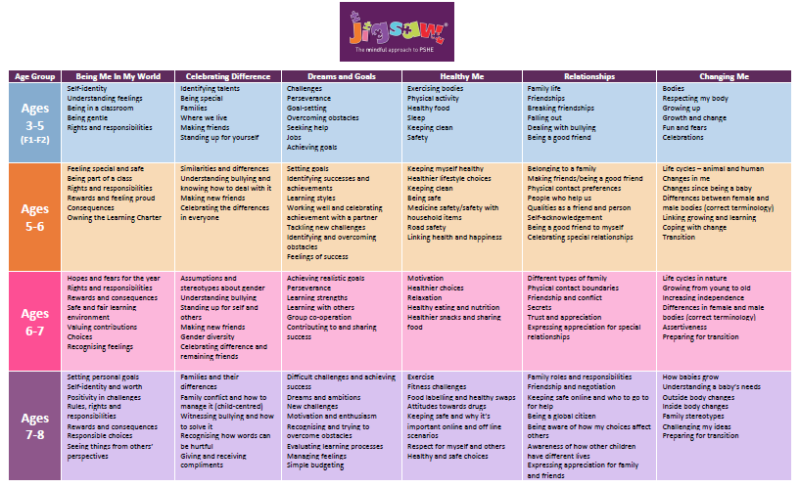

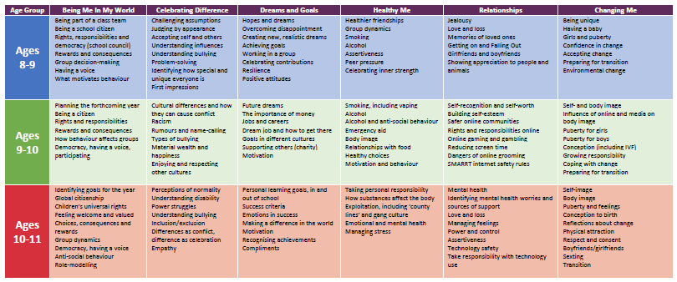

Additional, supplementary units are also available to ensure planning is adapted to meet the needs of our local community and individual classes.

